Re-Analysis of Current, Torque and Motor Speed Arrays of Data Collected from Spring 16

Zainab Hussein

3-30-2017

For the figures below, the interesting range of motor speed selected is 0-200 rad/s, for load torque is 0-20 N-m, and for supply current is 0-22 A. The number of columns and rows chosen for extrapolation are as follows:

1. Torque Arrays: 1863 columns and 224 rows
2. Motor speed Arrays: 224 columns and 22 rows
3. Current Arrays: 1863 columns and 39 rows

# Torque Arrays

## Constant Current

Expected hyperbola relation between motor speed and load torque at constant values of current.

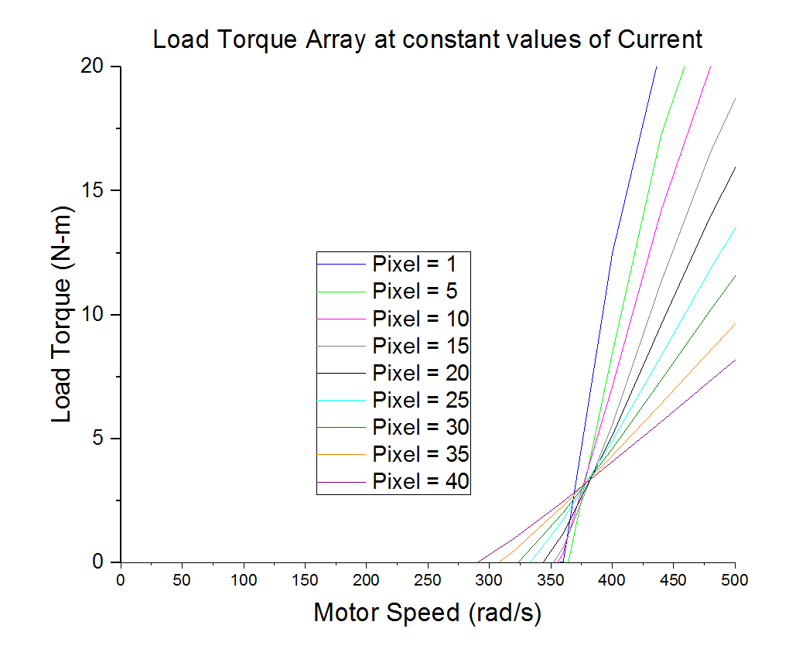

## Constant Motor Speed

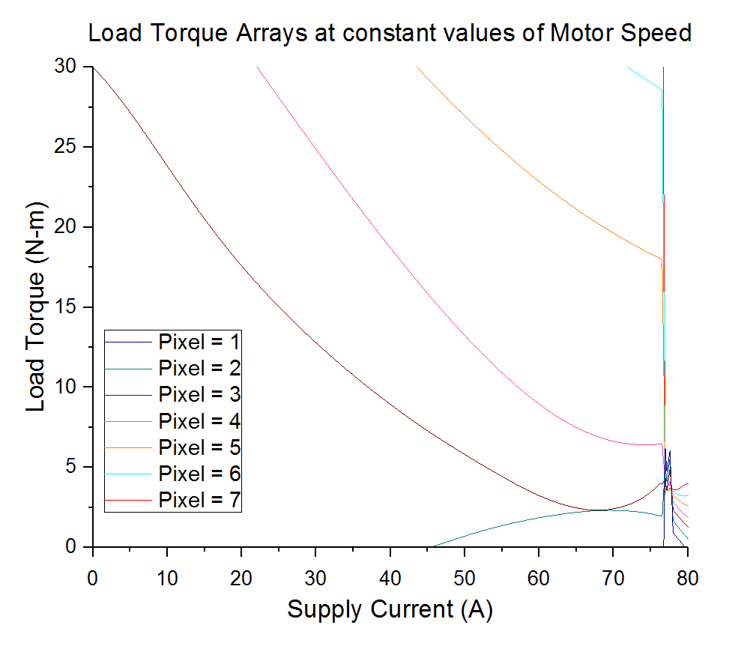

# Current Arrays

## Constant Torque

Expected linear relation between supply current and load torque at constant values of torque.

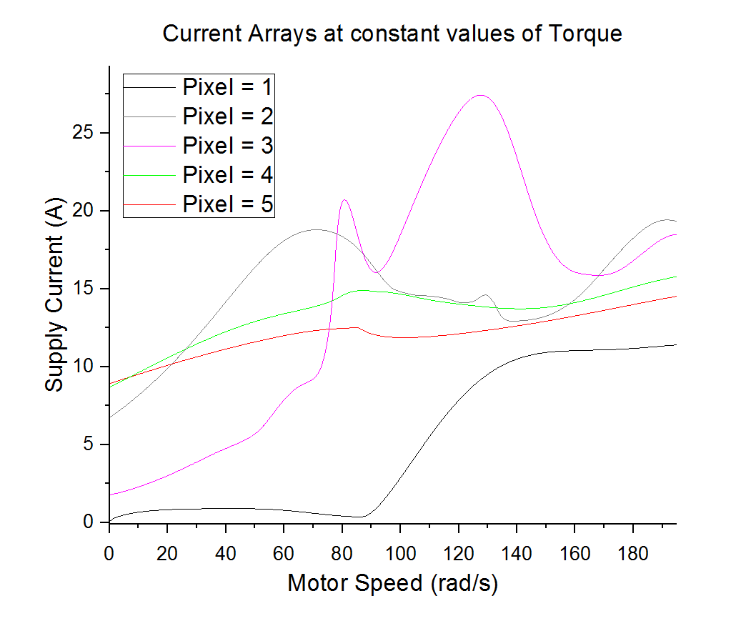

## Constant Motor Speed

Expected linear relation between supply current and load torque at constant values of torque.

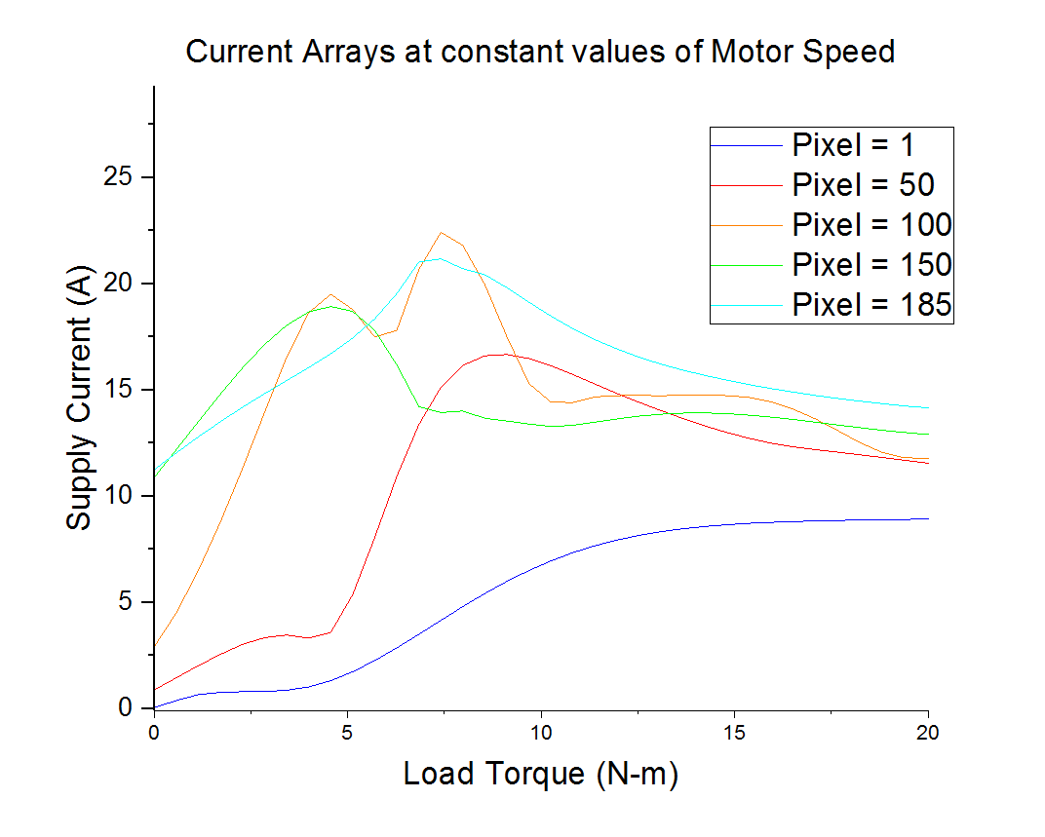

# Motor Speed Arrays

## Constant Torque

Expected linear relation between motor speed and supply current at constant values of torque.

## C:\Users\husseinz\Desktop\Physics\Origin Analysis\recalculated\Motor Speed Arrays\motorSpeedArrays_constantTorque_MT.PNG

## Constant Current

Expected hyperbola relation between motor speed and load torque at constant values of current.

